|  |
| --- |
| Circle Language Spec: Commands |

## Parameters in a Command Call in a Diagram

This article demonstrates a situation of command objects.

This article illustrates how parameters in a command could look in a diagram.

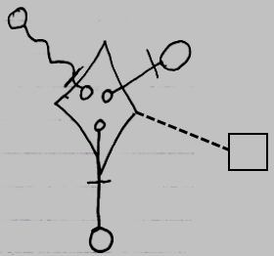

The diamond shape is a command call. What makes it a command call, is that it is tied to its command definition, the square, with a class line, the dashed line. The circles inside the diamond are the parameters. The parameters are tied to objects on the outside with parameter passings. The parameter passings are the lines connecting the smaller circles inside the diamond, the parameters, to the larger circles ouside the diamond. Parameter passings are explained later in the *parameter* articles.